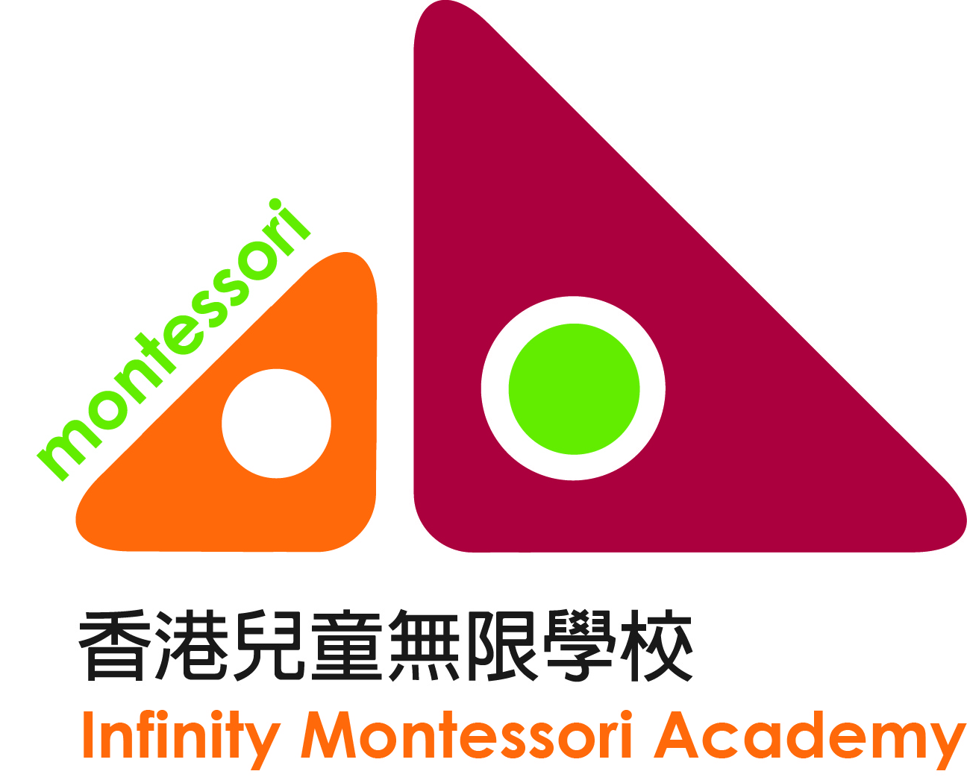
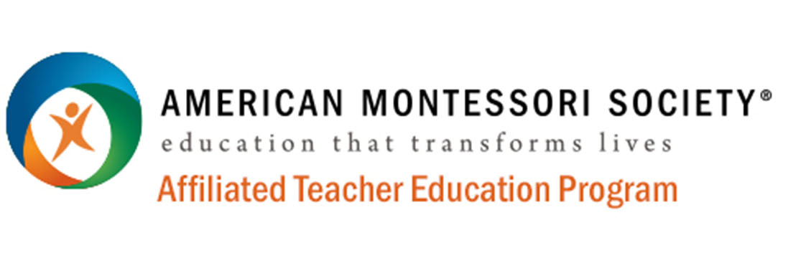

AMS Introduction to Montessori Classroom Practice
Application Form

☐ Infant and Toddler (Age 0-3) 2023-24 ☐ Early Childhood (Age 3-6) 2023-24

Personal information *Please delete where inappropriate.
Applicant’s Name in English ^{Note 1} (Mr./Miss/Mrs./Ms*): |  | Applicant’s Name in Chinese:
Sex: | Age: | HKID/Passport No.:
Job Industry: | Occupation: | Email Address:
Home Address:
Phone: |  | Date and Place of Birth:
Mother Tongue: Other Language: |  | Status: Single / Married / Divorced *
Education: Post-secondary Certificate/Diploma/Associate or Bachelor Degree / Others:
Note 1: this name will be used to issue the official certificate

Have you ever been convicted of a crime in a court of law? (Please put a in the box)
☐ Yes. Details:
☐ No.

Help us learn more about you:

1) How did you know about our Teacher Education Programme?
☐ Our website ☐ Online forums ☐ Friends ☐ Relatives
☐ My child studies at ICW. (name(s) of child/children: )
☐ Others (Please specify):

2) Your status is (You can choose more than one option)
☐ I do not have any child at the moment, but I wish to in the future
☐ I am pregnant/My spouse is pregnant (How many weeks? )
☐ I have a child/children (Age: M/F* Is your child a preterm baby? No / Yes*）
(Age: M/F* Is your child a preterm baby? No / Yes*）
☐ I help others take care of their children (Age: M/F* M/F* ）
☐ I work in the education field (Please specify: )

Application Procedure:

- Please complete and send this application form with the following documents by email to infinitycw@gmail.com
- A copy of your post-secondary Certificate/Diploma/Associate or Bachelor Degree.
- Tuition fee: HK$6,800
- Payment method: by cheque or bank transfer.
- By cheque: make your cheque payable to “Infinity Montessori Academy”; write your name on the back and send it to: Infinity Montessori Academy, 8 Somerset Road, Kowloon, Hong Kong
- By Bank Transfer:
  - Account Name: Infinity Montessori Academy
  - Account No: HSBC #139-172449-838

Terms and Conditions:

- IMA reserves the right to reject any application in any circumstances and for whatever reasons. Payment of fees should only be construed as conditional acceptance of application.
- IMA reserves the right to replace the speaker and/or change the contents, venue and/or time as may be necessary. IMA also reserves the right to cancel a course if there is an insufficient number of enrolments. In every case, IMA will make every effort to minimize the inconvenience caused and will give notice to all affected students of any such changes as early as possible.

Minimum Entry Qualifications
- Post-secondary Certificate/Diploma/Associate or Bachelor Degree (in any discipline)

Medium of Instruction
- Chinese and/or English. Coursework can be submitted in Chinese.

Applicant who satisfactorily completed the program will be awarded with
- American Montessori Society Certificate of Completion
- Hong Kong Montessori Research and Development Association Teacher Certificate of Completion

Use of Personal Data

IMA intends to use your personal data (i.e., your name, contact details, and other relevant information) for promotion of OUR education and training programmes, activities and services, but we will not use your data unless we have receive your consent. IMA will not share your personal information with third parties for their direct marketing purposes.

Please put a in the box to indicate your consent

☐ I AGREE that IMA may use my personal data for the purpose of promotion of IMA’s education and training programmes, activities and services as indicated above.

Full Name: Applicant’s Signature: Date:

Declaration
I declare that all information provided in this enrolment form and the accompanying documents are, to the best of my knowledge, true, accurate and complete. I have read and accepted all the terms and conditions of this application form.

Applicant’s Signature: Date:

