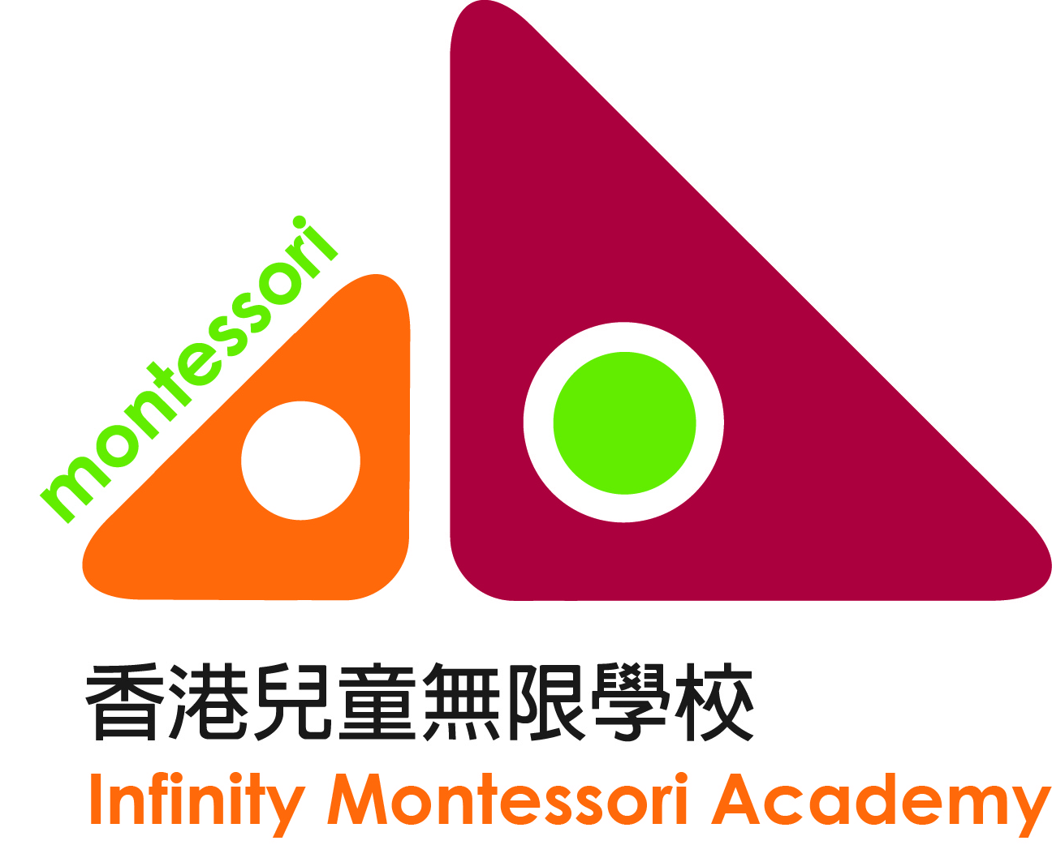

Infinity Montessori Academy
International Montessori Early Childhood Teacher Education Programme
(2019-2020)
Application Form
Photo

- Personal information

Applicant’s Name in English (Mr./Miss/Mrs./Ms*): |  | Applicant’s Name in Chinese:
Sex: | Age: | Ethnic Background:
Job Industry: | Occupation: | Working Hours: From to
Home Address:

Contact No.: (Home)  (Mobile)  (Work) |  | Place of Birth:  Date Of Birth :
Email Address:

Mother Tongue: |  | Status: Single / Married / Divorced *
First Language: |  | Other Languages:
*Please delete where inappropriate.

- Emergency Contacts

Person to Notify (Name): | Relationship: | Phone No.:

- Education Background (you may fill in the following or send us a resume)
List in chronological order all colleges, universities, and professional schools attended

Date | School (Name and Location) | Qualification received
List of Montessori Trainings/ Courses

Date | School (Name and Location) | Nature (workshop, course, etc.)

List of employment you have held

Date(mm/yy-mm/yy) | Employment and Name of Organization/ Company | Leaving Reason

- Have you ever been convicted of a crime in a court of law? (Please put a in the box)

☐ Yes. Details:
☐ No.

- Do you have any valid First Aid License?

☐ Yes. Expiry Date:
☐ No.

- Help us learn more about you:

1) How did you know about our Teacher Education Programme?
☐ Our website ☐ Online forums ☐ Friends ☐ Relatives
☐ My child studies at ICW. (name(s) of child/children: )
☐ Others (Please specify):

2) Your status is (You can choose more than one option)
☐ I do not have any child at the moment, but I wish to in the future
☐ I am pregnant/My spouse is pregnant (How many weeks? )
☐ I have a child/children (Age: M/F* Is your child a preterm baby? No / Yes*）
(Age: M/F* Is your child a preterm baby? No / Yes*）
☐ I help others take care of their children (Age: M/F* M/F* ）
☐ I work in the education field (Please specify: )

3) Do you have support from your spouse to finish the whole programme?
☐ Yes. My spouse supports me to finish the whole programme.
☐ No. My spouse has doubts on the programme.
☐ No. My spouse does not know my application to the programme.
☐ I do not have a spouse.

Application Procedure:

- Please complete and send this application form with the following documents by email to infinitycw@gmail.com
- Mission statement, in Chinese or English, at least 1000 words, may include a short story about your childhood, personal philosophy on education, your understandings on Montessori education, reflection on Montessori education, reflection on Hong Kong early childhood education, expectation on yourself, expectation on the course, expectation on your children (if any) or students.
- A copy of your post-secondary Certificate/Diploma/Associate or Bachelor Degree.
- Application fee: HK$800 (non-refundable) by cheque or bank transfer.
- By cheque: make your cheque payable to “Infinity Montessori Academy”; write your name on the back and send it to: Infinity Montessori Academy, 8 Somerset Road, Kowloon, Hong Kong
- By Bank Transfer:
  - Account Name: Infinity Montessori Academy
  - Account No: 012-816-00051894 (Bank of China)

- We will contact you for the first interview. We appreciate if your spouse can take the interview with you.

For successful applicants only: documents and fees required

- Three letters of recommendation;
- Official Transcript of College Degrees (must be evaluated by an outside agency to determine their equivalency to a United States degree.)
- Tuition fee: HK$64,000 (any costs of manuals, books, supplies and materials are not included)
Payment Method : 2 instalments by cheque or bank transfer
    - 1st instalment: HK$32,000 (28 February 2019)
    - 2nd instalment: HK$32,000 (30 April 2019)
- Student Membership Fee (as at 2019-2020) (non-refundable)
  - Agency#1 : US$225
  - Agency#2 : US$164
- Manuals: approx. US$450
- Field visit fee during practicum: HK$800/ visit (Field consultant will visit and advise the practicum student at least 3 times during the practicum. Transportation fee is not included.)

Terms And Conditions:

- Application fee is non-refundable, except in the event of which the application is rejected by the Admissions Department.
- IMA reserves the right to reject any application in any circumstances and for whatever reasons. Payment of fees should only be construed as conditional acceptance of application.
- IMA reserves the right to replace the speaker and/or change the contents, venue and/or time as may be necessary. IMA also reserves the right to cancel a course if there is an insufficient number of enrolments. In every case, IMA will make every effort to minimize the inconvenience caused and will give notice to all affected students of any such changes as early as possible.

Minimum Entry Qualifications

- Post-secondary Certificate/Diploma/Associate or Bachelor Degree (in any discipline)

Medium of Instruction

- Chinese and/or English. Coursework can be submitted in English, or subject to approval in Chinese. Manuals in English. Handouts in Chinese and/or English.

Use of Personal Data

IMA intends to use your personal data (i.e., your name, contact details, and other relevant information) for promotion of OUR education and training programmes, activities and services, but we will not use your data unless we have receive your consent. IMA will not share your personal information with third parties for their direct marketing purposes.

Please put a in the box to indicate your consent

☐ I AGREE that IMA may use my personal data for the purpose of promotion of IMA’s education and training programmes, activities and services as indicated above.

Full Name: Applicant’s Signature: Date:

Declaration
I declare that all information provided in this enrolment form and the accompanying documents are, to the best of my knowledge, true, accurate and complete. I have read and accepted all the terms and conditions of this application form.

Applicant’s Signature: Date:

